#### Biobank Information Leaflet

|  |  |
| --- | --- |
| **Name of Health Research Biobank:** | St. James’s Hospital Histopathology Biobank |
| **Charity number:** | CHY 16085 (Biobank Ireland Trust) |
| **Principal Investigator (PI):** | Dr Richard Flavin |
| **Biobank relationships/partnerships:** | St James’s Hospital is a teaching hospital, linked to Trinity College Dublin and the Trinity Translational Medicine Institute (located at St. James’s Hospital) |
| **Data Controller:** | St James’s Hospital |
| **Who to contact for Biobank information:** | Biobank Team:  Address: Department of Histopathology, St James’s Hospital, Dublin 8.  Telephone: 01 410 3336  Email*:* [biobank@stjames.ie](mailto:biobank@stjames.ie) |
| **Who to contact for data protection information:** | Data Protection Officer: [dataprotection@stjames.ie](mailto:dataprotection@stjames.ie) |

**Invitation:** You are invited to take part in the St James’s Hospital Histopathology Biobank. This is a health research biobank which collects biological samples (blood and tissue) and healthcare data, donated by people for health research. This biobank works with researchers who use these samples and healthcare data to learn more about cancer and understand it better. Before you decide if you would like to take part, please read this information leaflet carefully. Your nurse or doctor can answer any questions you may have.

**How a biobank can help future patients**

**Key Words:** These key words will help you understand this leaflet

|  |  |
| --- | --- |
| When we say… | We mean… |
| Academic research | Research which is carried out in hospitals, universities, colleges and research institutes. |
| Biobank | A large collection of biological samples and healthcare data, donated by people for health research. |
| Biobank team | The team running the biobank, for example, scientists, nurses, pathologists. |
| Biological samples (‘samples’) | Samples donated by people for research. Samples may include blood, urine or tissue that is not required for diagnosis. |
| DNA | Your DNA makes you who you are by instructing your cells to carry out specific tasks. |
| Genetic research | Research which examines peoples’ genetic information (genes) to help us understand how cancerbehaves. |
| Healthcare data | Information in your hospital chart, hospital electronic patient record and other hospital databases. It includes your name, address, test results, images/scans. It may include other types of personal data such as health-related lifestyle data. |
| Health-related companies | Businesses which develop new diagnostic tests, treatments, medicines, medical devices, for profit. Examples are start-ups, academic spin-out companies, diagnostic and biopharmaceutical companies. |
| Identifiable data | This is information that may identify you, such as your name, address, date of birth, hospital number. |
| Non-identifiable data | Information that might identify you has been removed and replaced with a unique code. This code is used instead of your name, address, date of birth, hospital number. |
| Principal Investigator | The person responsible for a biobank or specific research study, for example, a hospital consultant or hospital doctor. |
| Research Ethics Committee (REC) | An independent group of people who review each study to ensure that research is carried out ethically and safely and that your rights are protected. |
| Research studies | Research to learn more about cancerincluding cancer genetic research, how cancer changes over time, cancer growth, prevention, early detection, diagnosis, new tests and treatments and the causes of cancer in families. |
| Researchers | The scientists, doctors, nurses and other healthcare professionals doing cancerresearch. They may come from hospitals, universities, research institutes or health-related companies. |

**Section A: Taking Part**

1. **Why are biobanks important?**

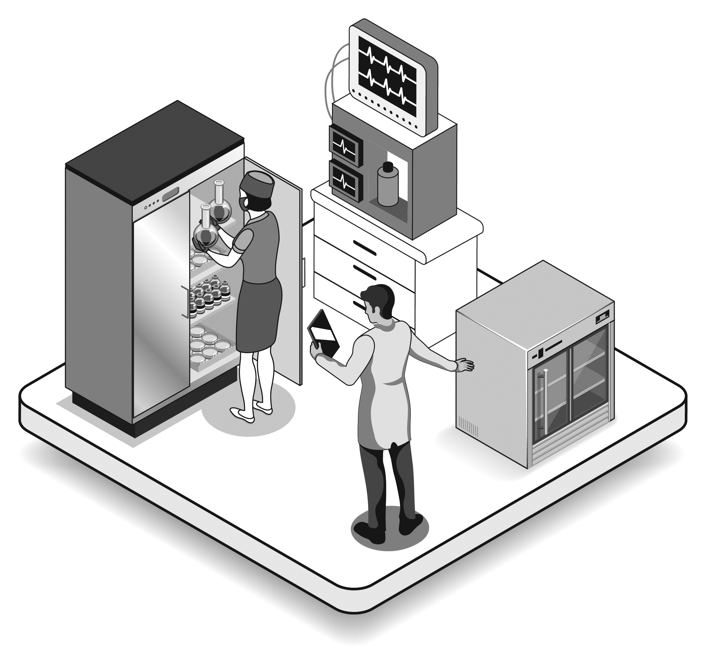Health research is important because it helps us understand more about health and disease and the best way to treat illnesses. Health research takes many years and needs large numbers of people to donate their samples and healthcare data. Biobanks can speed up research by having samples and data ready to use when researchers need them. The aim of this biobank is to learn more about cancer.

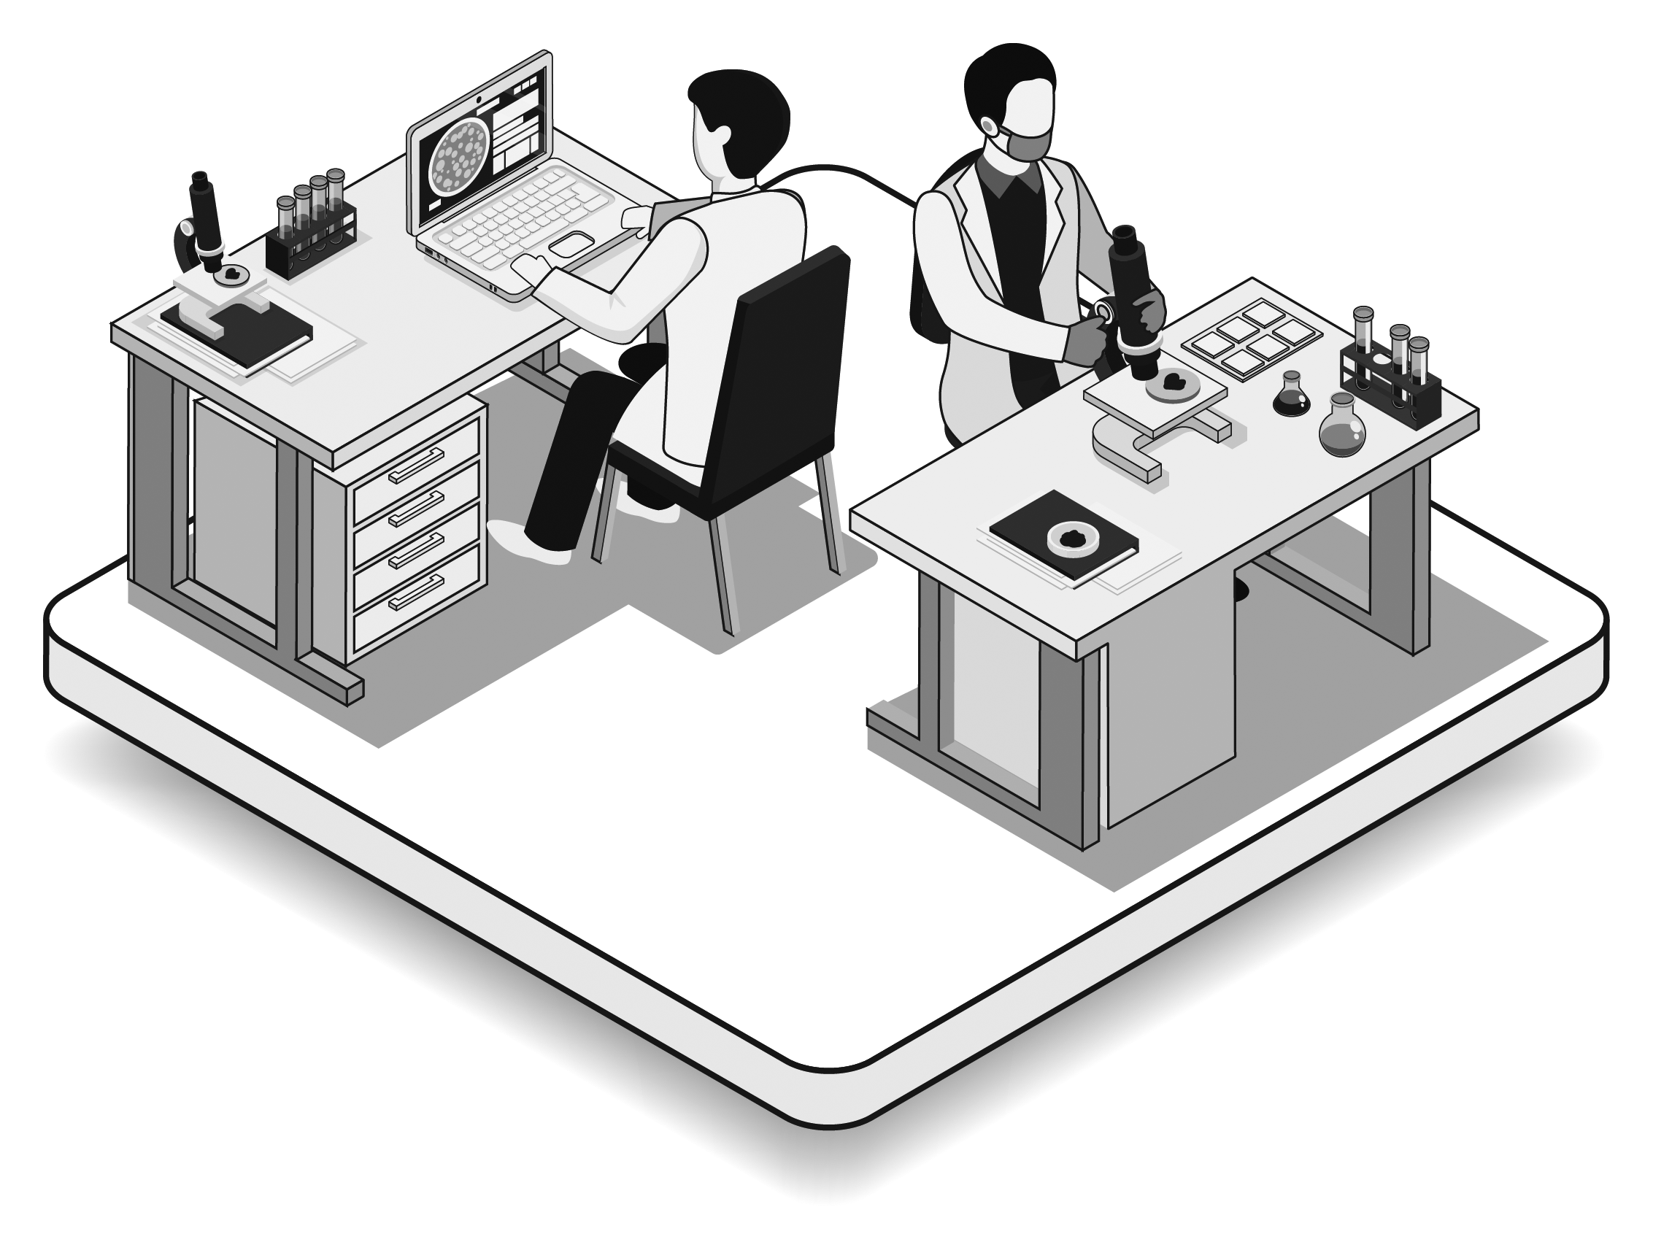Researchers may investigate different aspects of cancer including cancer genetic research, how cancer changes over time, cancer growth, prevention, early detection, diagnosis, new tests and treatments and the causes of cancer in families. Your samples will be stored until researchers need them. Your healthcare data will always be useful to researchers even after your samples have been used. For this reason, your healthcare data may be stored indefinitely (forever).

Your samples and data may be included in many research studies. The biobank may share your non-identifiable samples and healthcare data with cancer researchers working around the world (more detail in Section C). You can find more information about biobanks on Biobank Ireland Trust’s website ([www.biobankireland.com](http://www.biobankireland.com)).

1. **What will happen if I take part?**

If you would like to take part, please read this leaflet and sign the consent form at the end. You will be given a copy of your signed consent form and this leaflet to keep. Your nurse or doctor can discuss this leaflet and consent form with you.

If you consent the biobank will collect and store:

* **Tissue samples:** Ifyou have an operation, a qualified medical scientist or doctor will decide if extra tissue can be taken for the biobank.
* **Blood samples:** When you havea routine blood test your doctor or nurse may take an extra sample to give to the biobank. This is a small sample – about 2 tablespoons.
* **Historical samples and associated healthcare data:** If you had an operation or biopsy in the past, older tissue samples belonging to you may already be stored at St James’s Hospital. The biobank would also like to include these samples and associated healthcare data in the biobank.
* **Healthcare data:** This will be stored as well as your biological samples.

1. **What are the benefits to me?**

Research can lead to better diagnostic tests, treatments and a better quality of life for people living with cancer. The treatments we have now were developed as a result of past research studies. Our biobank collects samples and healthcare data for future research therefore we cannot predict now, what discoveries researchers may make in the future. It takes many years to do research and the results are experimental (of unknown value) for a long time. This means that your care may not be influenced by research and you may not benefit personally. However, you are contributing to improving healthcare in the future by participating in the biobank.

1. **Are there any risks to me?**

**Data privacy:** As with any medical records, there is a very low risk of accidental disclosure of your healthcare data. However, this is very unlikely as every effort will be made to protect your privacy (see Sections B and C).

**Sample donation:**

Blood sample: A blood sample may cause bruising or slight discomfort.

Diagnostic value: It is very unlikely that biobanking could affect a patient’s diagnosis. This is because biobanking can only take place when extra tissue is available.

1. **Do I have to take part?**

No**.** You do not have to take part. It is up to you to decide if you would like to take part. Your decision will not affect your medical care now or in the future.

1. **What if I change my mind?**

You can change your mind at any time. If you change your mind contact the biobank (see Page 1) to let the team know. From this point on your samples and healthcare data will not be used for research. However, it will not be possible to destroy samples and healthcare data already included in research, as this could impact on the research results. The biobank has to keep a record that you changed your mind and to record the destruction of your samples and healthcare data.

1. **What happens to the results from research?**

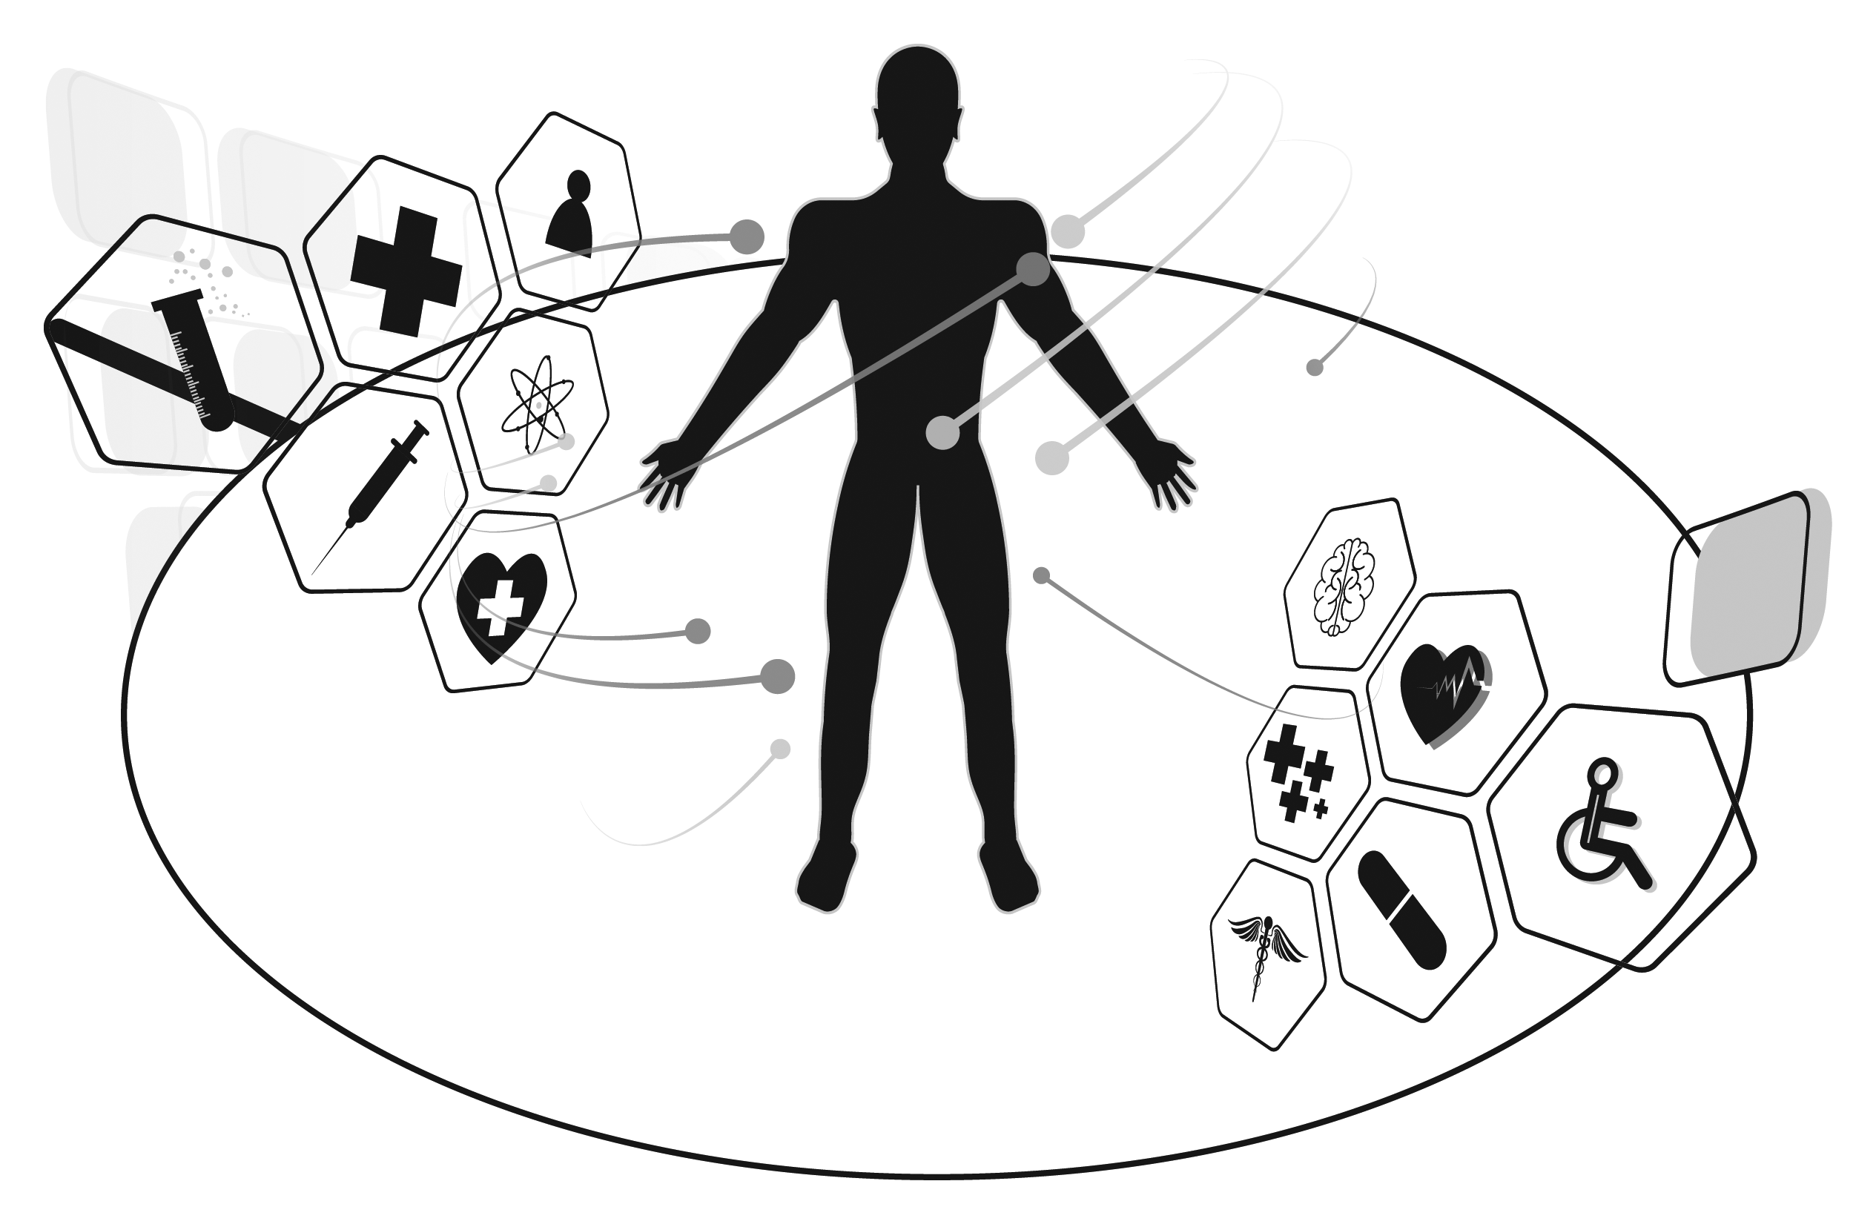Researchers usually publish their results in scientific or medical journals or present them at conferences so that others can learn from their research. You will not be identified in any journals or presentations. The biobank hopes research results will improve health care for future patients. The biobank cannot return research results to you.

**Section B: Biobank Management**

1. **How does the biobank protect me?**

The biobank has very strict governance procedures in place. Your samples and healthcare data can only be used in research approved by a hospital Research Ethics Committee **and** each ofthe following departments at St James’s Hospital;

1. The Office of Research & Innovation
2. The Department of Legal & Insurance
3. The Data Protection Officer
4. The Biobank Team also review each study

The Principal Investigator and research institution must sign legal agreements before samples and healthcare data can be shared. This ensures researchers, including those in health-related companies, use your samples and healthcare data only as agreed (see Section C).

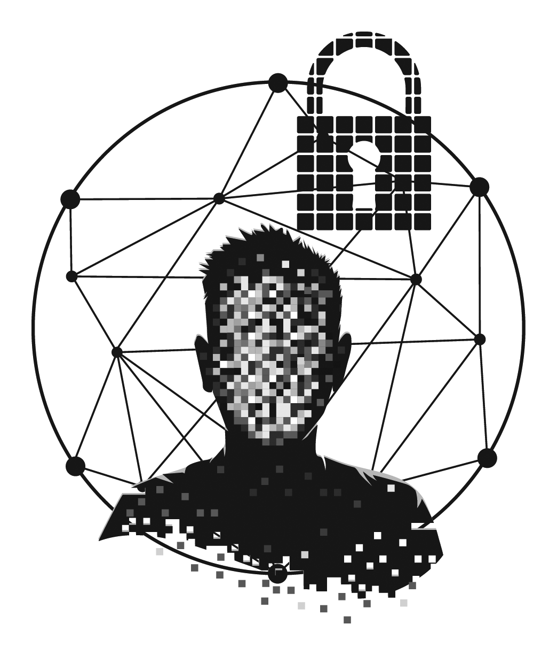Your privacy is very important to the Biobank. Your healthcare data will be treated confidentially. The Biobank Team undergo data protection training and are bound by hospital confidentiality rules. The biobank has arrangements in place to keep your healthcare data safe including restricted access to buildings, offices and computers. Databases are also password protected. The privacy policy for St James’s Hospital can be found here: <http://www.stjames.ie/InformationGovernance/PrivacyPolicyCondensed/>

1. **Has this biobank been approved by a Research Ethics Committee?**

Yes. This health research biobank was approved by the Tallaght University Hospital and St James’s Hospital Joint Research Ethics Committee.

1. **How is the biobank funded?**

This biobank receives funding from the charity ‘Biobank Ireland Trust’ ([www.biobankireland.com](http://www.biobankireland.com)). This funding does notcover the cost of running the biobank. For this reason, the biobank charges researchers a small fee to help cover the cost of collecting, storing and managing samples and data. Fees go into the St James’s Hospital Foundation biobank account to help keep the biobank operating. The biobank does not make a profit from collecting or sharing your samples and data for health research.

1. **Will I be paid for my involvement?**

No. You will not be paid to take part in this biobank. If you decide to take part, it is hoped that your samples and data will help other cancer patients in the future.

**Section C: What does the biobank do with my healthcare data?**

1. **Why does the biobank need to collect my healthcare data?**

Your samples cannot be included in research studies without your accompanying healthcare data. For example, your healthcare data can help researchers choose the right samples for their research or make sense of their results. You will be asked to share your healthcare data with researchers if you decide to take part in the biobank.

1. **What type of healthcare data will be collected?**

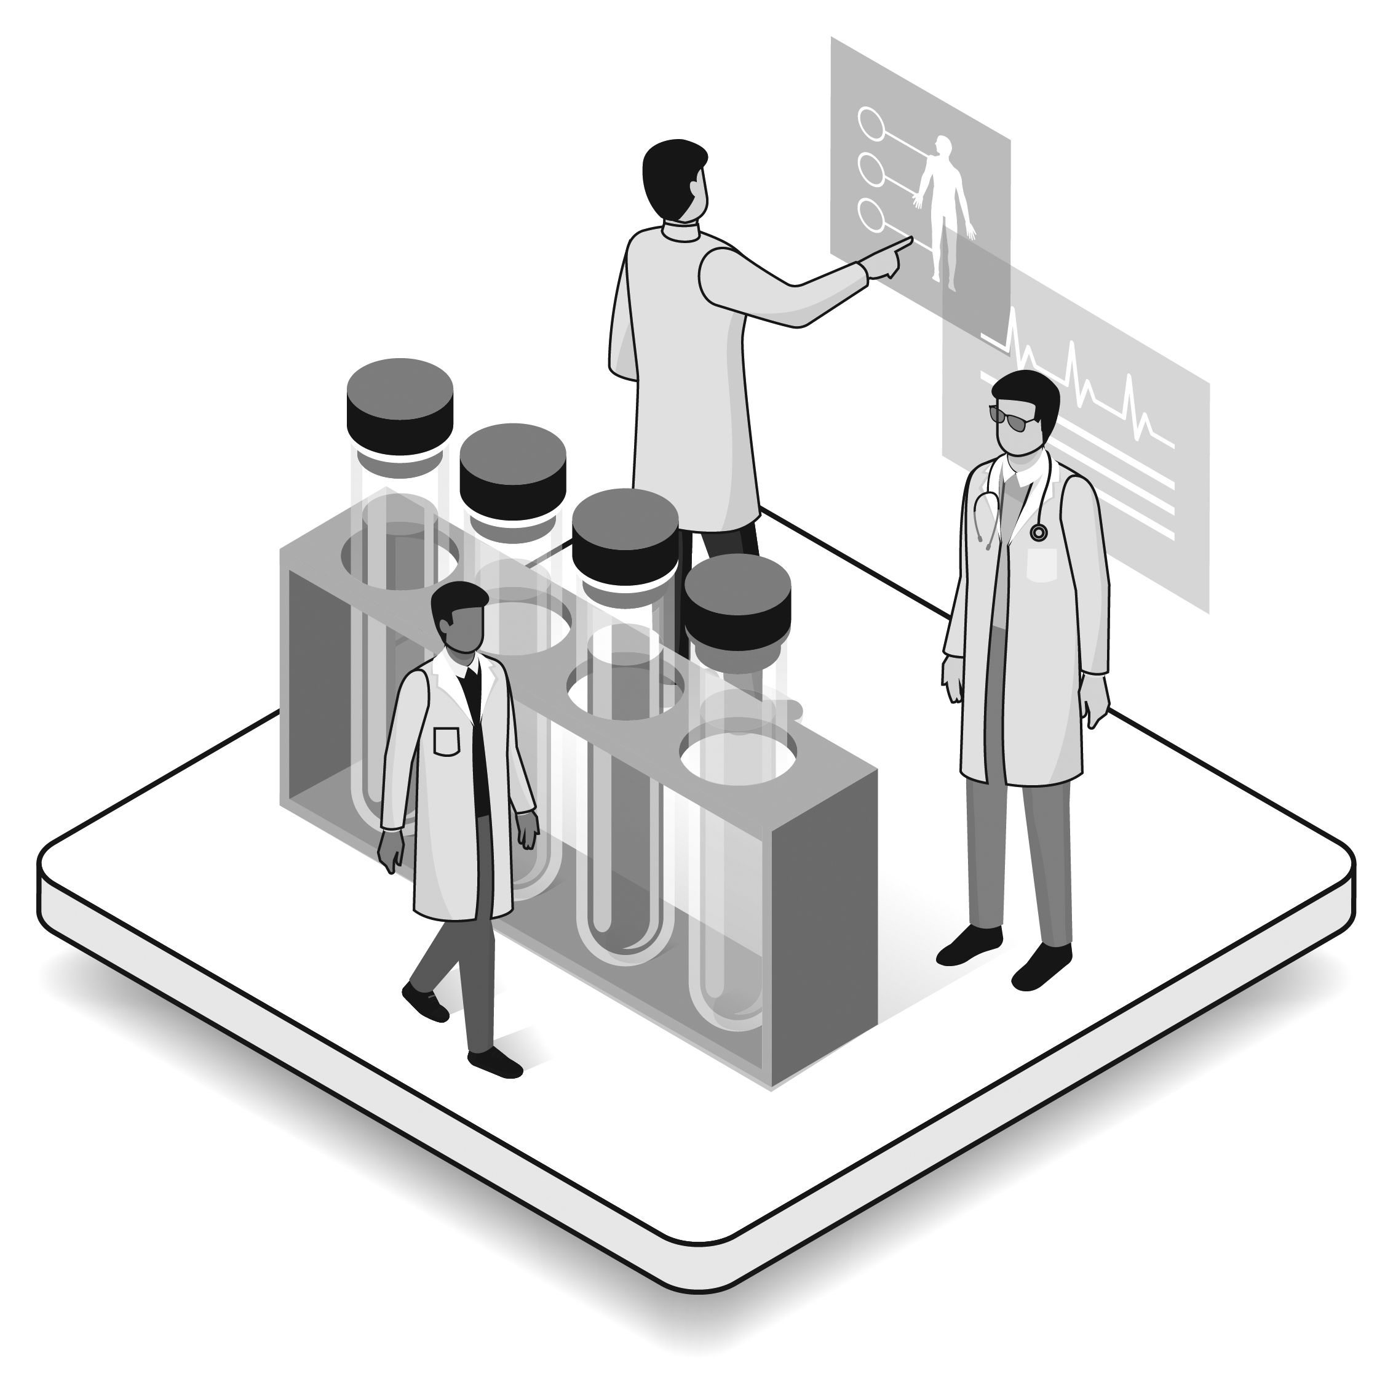The biobank will collect healthcare data from your hospital chart, hospital electronic patient records and other hospital databases. The biobank team and cancer researchers working under a Principal Investigator at St James’s Hospital may know your identity so that they can follow your care and treatment.

**The biobank will collect and store the following healthcare data:**

* Name, address, gender, date of birth, hospital number, lab identifiers
* Results: radiology (X-ray, CT, MRI), histology (type of cancer), genetic & molecular diagnostic tests (tests that indicate the best treatments for patients)
* Treatments: any medicines given to you and how you responded
* Medical history: previous illnesses, treatments received, medicines, medical procedures

1. **How is my healthcare data stored and shared?**

The biobank stores healthcare data on a secure database, called a Biobank Information Management System (BIMS). The BIMS is located at St James’s Hospital. Your healthcare data may be stored indefinitely (forever). Samples and healthcare data will only be shared as outlined in Section B: Biobank Management. Your healthcare data may be shared as:

**‘Identifiable data’**: The biobank staff and researchers working at St James’s Hospital will know your identity, so they can follow your care and treatment. Only researchers working directly under a Principal Investigator at St James’s Hospital will have this privilege.

**‘Non-identifiable data’**: Researchers working outside St James’s Hospital will receive ‘non-identifiable data’. This means that information that identifies you is removed and replaced with a unique code. This code is used instead of your name, address, date of birth or hospital number. These researchers may work in universities, hospitals, health-related companies or research institutes around the world. Healthcare data and sample sharing can only take place as described in Section B: Biobank Management.

1. **Working with health-related companies**

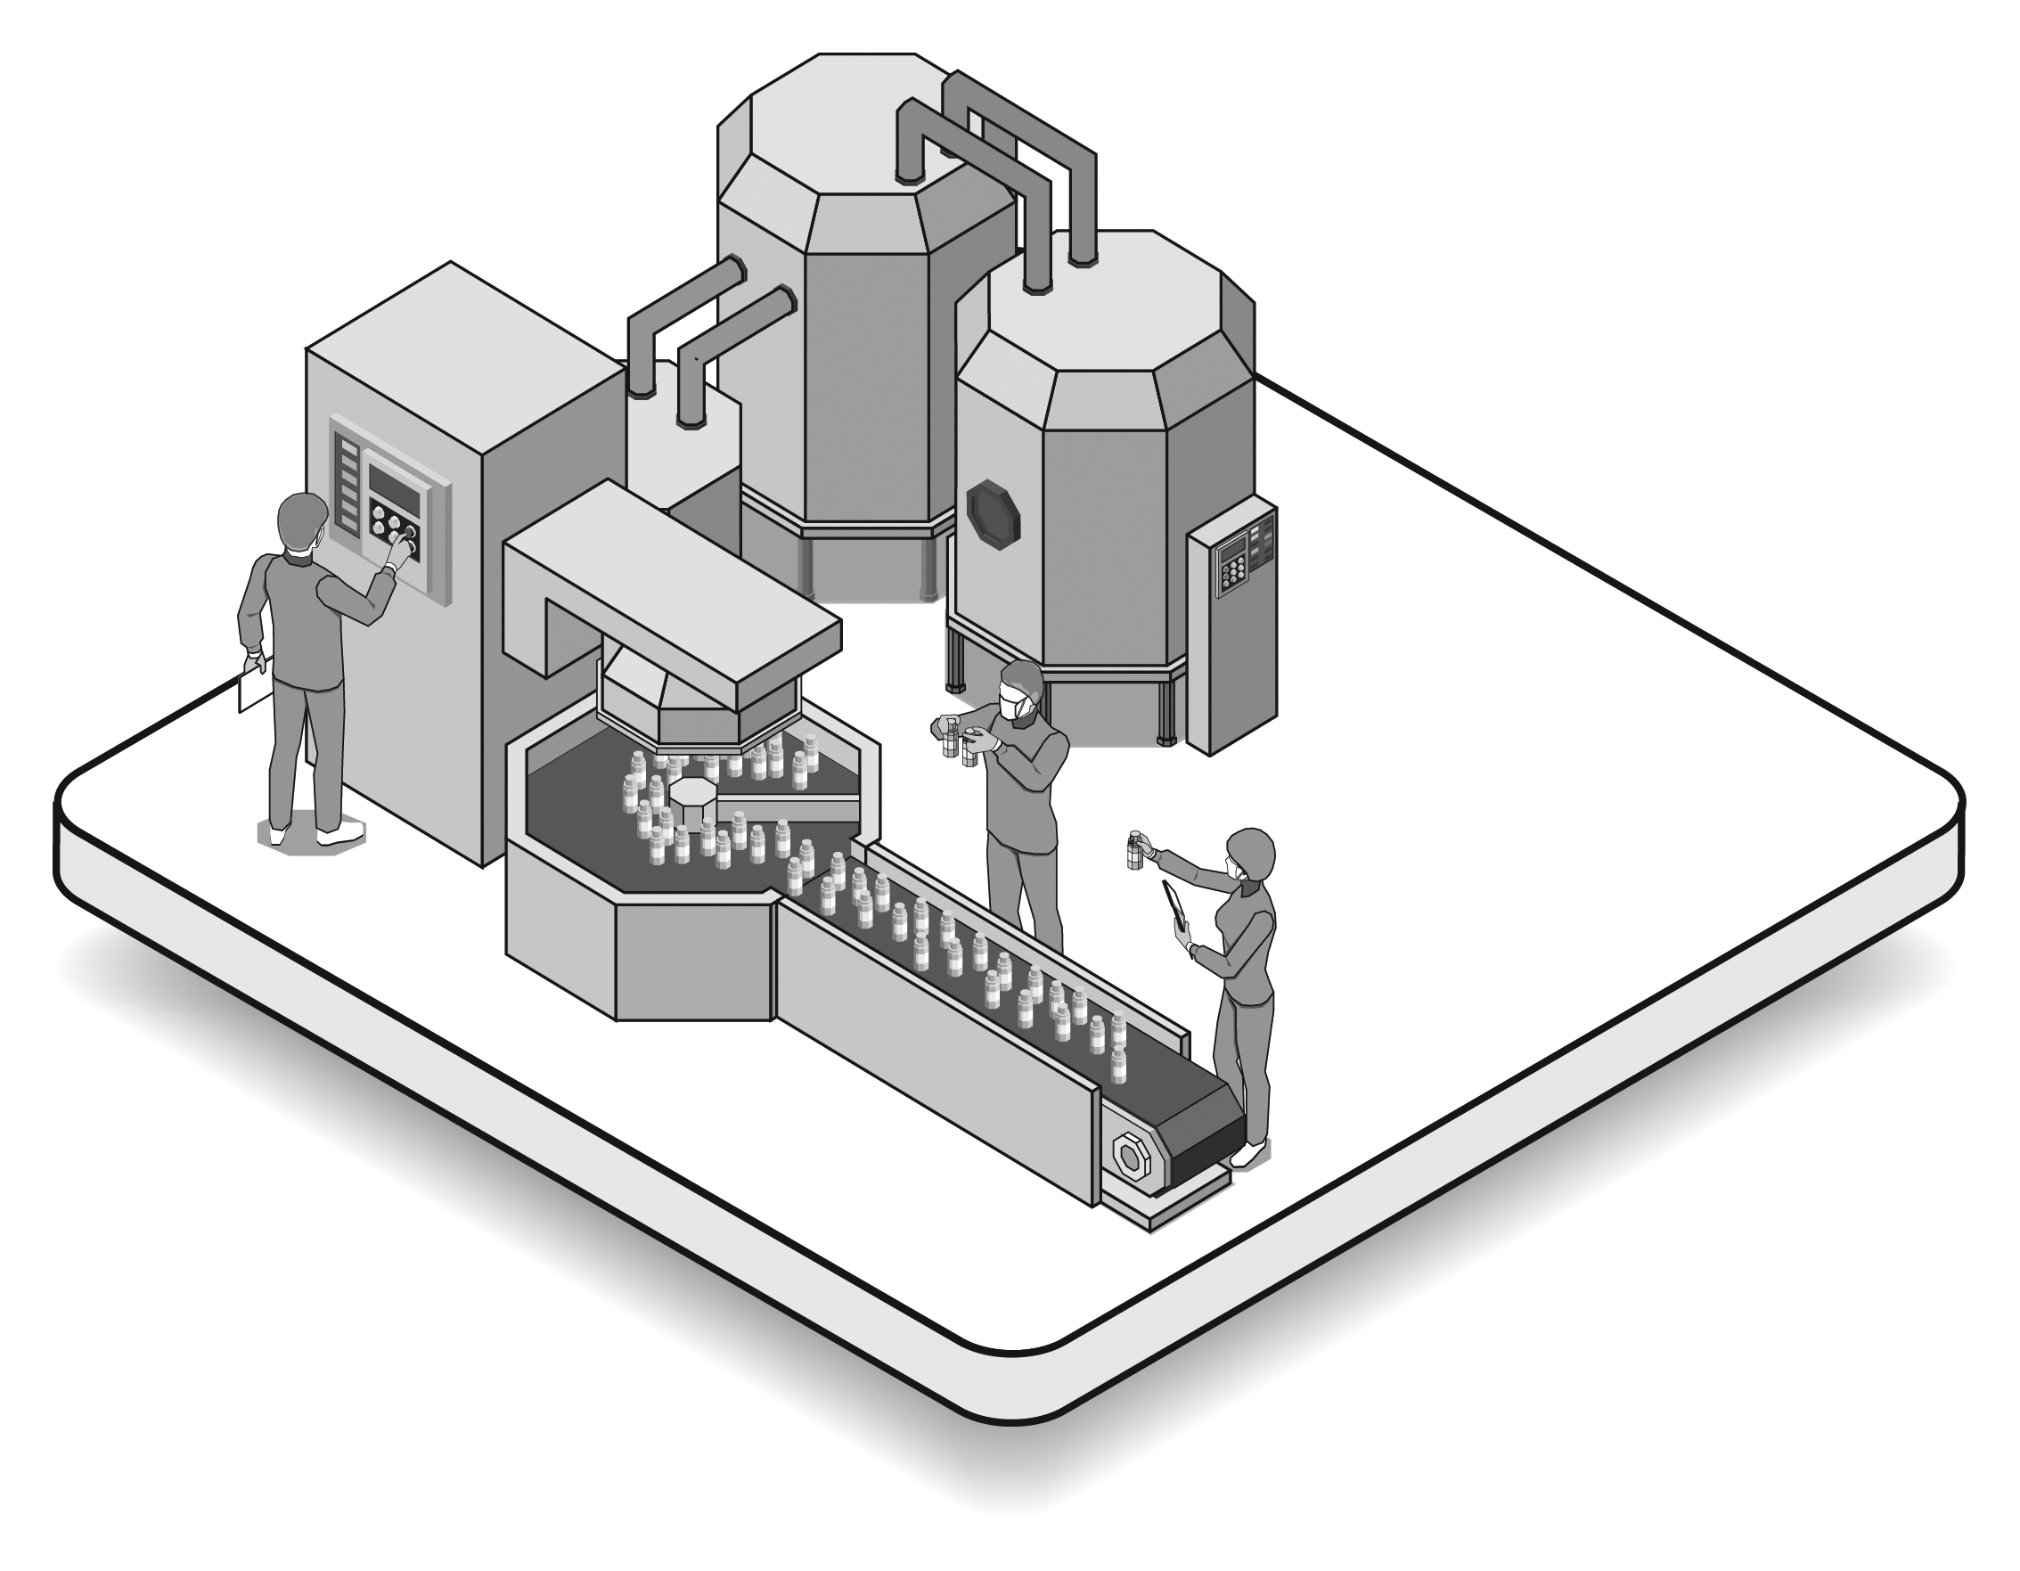For the purposes of cancer research, the biobank may work with health-related companies and share samples and non-identifiable healthcare data with them. These companies manufacture and develop new medicines, tests and treatments in a highly regulated environment. Academic researchers can discover very early information and identify the possibility of new medicines and treatments. Due to high-costs and the expertise involved, health-related companies must build on these discoveries to deliver these new medicines and treatments for patients.

Health-related companies must have ethical approval from a hospital Research Ethics Committee and sign all necessary legal agreements. The agreements outlined in Part 2: Biobank Management must be in place before samples and ‘non-identifiable data’ can be shared. Biobank participants will not receive money if research leads to a new test, treatment, medicine or medical device.

If you would like more information about the process of sharing your samples and healthcare data, contact the Biobank Team (Page 1).

1. **Working with the National Cancer Registry**

The biobank collects and stores and stores only pathology (cancer type data) and sample related data. If a researcher requires data that the biobank does not have, they may apply to the National Cancer Registry Ireland (NCRI) for this information. The NCRI is a state appointed body which collects data on all cancer patients in Ireland. The NCRI will assess applications for additional data on an individual basis. If you consent, the NCRI could provide the data that the biobank does not collect. For example, the number of patients who received a treatment and how each patient responded to that treatment. The NCRI will not identify patients. This is because each patient in the biobank is given a unique code. The NCRI uses these unique codes to avoid identifying patients.

1. **What are my rights?**

The biobank has data protection measures in place and is committed to ensuring that your rights under GDPR (General Data Protection Regulation) are protected. To find out more about your rights go to: <http://www.stjames.ie/InformationGovernance/PrivacyPolicyFull/>. St James’s Hospital is the data controller for this biobank. The biobank will share your healthcare data to help with scientific research (in the public interest). We also ask for your consent as a data protection safeguard, in accordance with the Irish Health Research Regulations 2018.

**Biobank Consent Form**

|  |  |
| --- | --- |
| **Name of Health Research Biobank:** | St James’s Hospital Histopathology Biobank |
| **Biobank Contact**  **information:** | Biobank Tel: 01 410 3336  Email*:* [biobank@stjames.ie](mailto:biobank@stjames.ie) |

***ATTACH PATIENT ID LABEL***

**If you wish to participate in this biobank, all boxes in Part 1 must be ticked (√):**

|  |  |
| --- | --- |
| **Part 1: General** | **Tick √** |
| 1. I have read, or had explained to me, and understood the information leaflet. I have received a copy and have been able to ask questions. I understand that I can change my mind and withdraw from the biobank at any time. I understand this will not affect my medical care. |  |
| 1. I give permission to the biobank and cancer researchers working directly with the clinical team at St James’s Hospital to access my healthcare data in my hospital chart, hospital electronic patient records and other hospital databases for the purpose of cancer research. |  |
| 1. I give the biobank permission to collect and store my samples until researchers need them and my healthcare data indefinitely for the purpose of cancer research. |  |
| 1. I give the biobank permission to include my samples and healthcare data in cancer research studies. I understand research may include cancer genetic research, how cancer changes over time, cancer growth, prevention, early detection, diagnosis, new tests and treatments and the causes of cancer in families. |  |
| 1. I understand that my non-identifiable samples and data may be shared with cancer researchers who work in other hospitals, universities, colleges or research institutes, around the world for the purpose of cancer research. |  |
| **Please tick (√ ) if you agree to any or all of the following:** | |
| **Part 2: Historical samples, NCRI and health-related companies** | **Tick √ Yes or No** |
| I give permission to include my historical diagnostic samples and healthcare data from other procedures (such as an operation or biopsy) in the biobank. |  |
| I give the biobank permission to share identifiable data with the National Cancer Registry of Ireland (NCRI). I understand that the NCRI collects data on cancer. I give the NCRI permission to share my data with researchers on the condition that I am not identified. |  |
| I give the biobank permission to share my non-identifiable data and samples with health-related companies around the world only for the purpose of cancer research. I understand these companies may make new diagnostic tests, treatments, medicines or medical devices for profit. |  |

|  |  |
| --- | --- |
| **Patient name (PRINT):** | **Date:** |
| **Patient signature:** |

|  |  |
| --- | --- |
| **Nurse/Doctor taking consent (PRINT):** | **Date:** |
| **Nurse/Doctor signature:** |